CHRISTAL SEAS SCUBA CHRISTMAS PARTY MENU

SATURDAY 10 DECEMBER 2016, 7PM

The Mercure Hotel, Boundary Road, Norwich, NR3 2AY

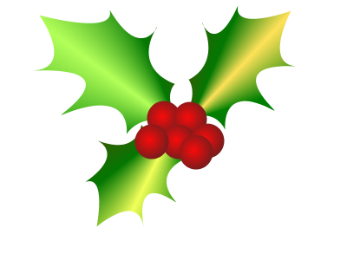

Roasted Butternut Squash soup, rosemary & shallot cream
Chicken, duck & red onion marmalade terrine, celeriac, rocket & toasted ciabatta
Goats cheese, poached pear & caramalised walnut salad, red chicory & rocket

Roast turkey, sausage in bacon, sage, onion & cranberry stuffing
Leek and stilton pot, chestnut & brioche crumb
Roasted cod loin, herb crust, buttered kale, chive cream sauce

Christmas pudding and brandy sauce
Clementine tart in chocolate pastry, chocolate sauce & orange cream
Cheddar & brie, crackers, grapes, caramalised onion chutney

Coffee & chocolate mint

